KENDRIYA VIDYALAYA SEC-2 RK PURAM SHIFT –II
ADMISSION SESSION: 2021-2022
SGC CANDIDATES
PROVISIONAL LIST FOR VERIFICATION OF DOCUMENTS: CLASS 1
BRING ORIGINAL AND ONE SET OF SELF ATTESTED PHOTOCOPIES OF DOCUMENTS FOR VERIFICATION. ERROR AT ANY LEVEL IN DOCUMENT SUBMITTED WILL BE REGULATED AS PER KVS LATEST ADMISSION GUIDELINES 2021-2022 ONLY.
DATE FOR DOCUMENT VERIFICATION: 05.07.2021 TO 07.07.2021
TIME: 12 NOON TO 2 PM
IF PARENTS DO NOT REPORT WITHIN STIPULATED TIME GIVEN, NO REQUEST FOR VERIFICATION WILL BE ENTERTAINED AND 2ND LIST WILL BE DISPLAYED
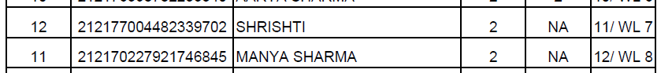

(Suresh Sharma) Awadhesh Dubey
Admission Incharge Approved/ Not Approved Principal
Prof. (Mrs) Jyotsna Tiwari
HOD DEAA
NCERT New Delhi

